<https://www.askdavetaylor.com/create_custom_stock_market_index/>

Individual stocks essentially reflect investor expectations of the future value of a company. If you believe that a particular company is going to grow bigger, to earn more next year than it does this year, you therefore also believe that the company is going to be worth more as an entity. Its current value is essentially the stock price * total number of shares of stock outstanding (e.g., issued and in the marketplace). This is what analysts call “market cap” and it can be calculated for any publicly traded firm quite easily.

the key indicator we want for a market index is the change in stock value over the desired period of time.

What period of time should we use? How about the usual 15-minute delayed ticker information of the value against its opening this morning?

For illustrative purposes, let’s grab a half-dozen additional tech stocks and see how they’re doing right now, as I write this blog entry: Microsoft (Nasdaq: MSFT) is +0.11, Apple (Nasdaq: AAPL) is +0.34, eBay (Nasdaq: EBAY) is +0.13, Yahoo (Nasdaq: YHOO) is -0.19 and Amazon (Nasdaq: AMZN) is -0.20.

A “favorite tech stocks index” can then be calculated by simply adding everything up: -0.04 + 0.11 + 0.34 + 0.13 + -0.19 + -0.20, giving us +0.15.

the S&P 500 is far more complicated than I’m suggesting, with a weighted floating value and all sorts of abstruse calculations to get its neat little number.

let’s just create our own index methodology based on the simplistic ideas presented herein. We’ll just add one more: a numeric index that’s actually the sum value of one share of each of the companies we’re tracking. If we go back to our tech stocks, here’s what we find out: Cisco is trading at $26.29, Microsoft at $31.02, Apple at $109.38, eBay at $33.99, Yahoo at $29.21 and Amazon at $61.49. Add them up and our base index number is 291.38. ADT Tech Six Index: 291.38 (+0.15).

#!/bin/sh

stocks=”CSCO MSFT EBAY AAPL AMZN YHOO”

getvalue=”/home/taylor/scripts/067-getstock.sh”

sumvalue=0

for stock in $stocks

do

value=”$($getvalue $stock)”

valuex100=”$(echo $value \* 100 | bc | cut -d. -f1)”

echo “$stock is currently trading at: $value”

sumvalue=$(( $sumvalue + $valuex100 ))

done

indexvalue=”$(echo “scale=2; $sumvalue / 100″ | bc)”

echo “ADT Tech Six Index: $indexvalue”

exit 0

When run, the output is clean and interesting:

$ sh calculate-index.sh

CSCO is currently trading at: 26.39

MSFT is currently trading at: 31.00

EBAY is currently trading at: 34.01

AAPL is currently trading at: 109.76

AMZN is currently trading at: 61.68

YHOO is currently trading at: 29.14

ADT Tech Six Index: 291.98

Imagine now that you modify the script to only output that last value by itself, and that you now recalculate this every sixty minutes with a cron job (I assume that you’re running a Linux server for your Web site, as most people are). It’d look like this:

sh build-index > $webhome/current.index.value

Now all you need to do in your actual Web page is include that value where you want it displayed.

<https://www.coindesk.com/sp-cryptocurrency-contextualizing-bitcoins-price-explosion/>

Ash Bennington; 8/15/2017

As a baseline way of thinking about the rise in the price of bitcoin consider this: Over the last 90 years, the average annual rate of return on the S&P 500 index has been just 9.8 percent.

If we compare bitcoin's performance this year to the average return of the S&P 500, it's immediately clear bitcoin's moonshot rise has outperformed this benchmark by a stratospheric 6,000 percent.

For a slightly different proxy of price movement, let's take a look at how long it took the S&P 500 to double in value to its current level. At press time, the S&P 500 Index is trading around 2,466. Cutting that number in half, we get 1,233.

The last time the S&P 500 traded below that level was August of 2010. So it took the S&P 500 almost seven years to double – 30 times longer than it took bitcoin to do the same.

bitcoin's very nature makes it quite challenging to compare it to stocks in an apples-to-apples way.

One of the virtues of investing broadly in stocks via the S&P 500 Index is diversification.

The S&P 500 is made up of a basket of 500 companies, comprising many of the largest publicly traded corporations in America.

The stocks in the S&P 500 are drawn from 11 different sectors across 24 different industry groups. That kind of diversification means people are shielded, in large measure, from risks to any one company and, to a lesser extent, shielded from risks to any one industry group or market sector.

Bitcoin, on the other hand, is an investment in a single asset. In a certain sense, investing in bitcoin is roughly analogous to investing in a single stock.

Although that metaphor probably doesn't go far enough, still. What you're really investing in is a single implementation of one technology, a single instance of code.

This means that investing in bitcoin rather than the S&P massively concentrates your risk, and as we've seen today, that risk can equate to hundreds of dollars per bitcoin.

Sent LinkedIn request to Ash asking him to be a sponsor.

TimeSeries Modeling

<https://www.analyticsvidhya.com/blog/2015/12/complete-tutorial-time-series-modeling/>

Is it stationary or non-stationary?

The mean of the series should not be a function of time rather should be a constant. The image below has the left hand graph satisfying the condition whereas the graph in red has a time dependent mean.

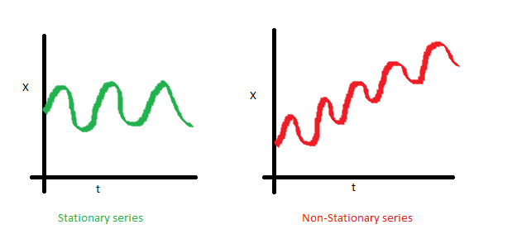

The variance of the series should not a be a function of time. This property is known as homoscedasticity. Following graph depicts what is and what is not a stationary series. (Notice the varying spread of distribution in the right hand graph)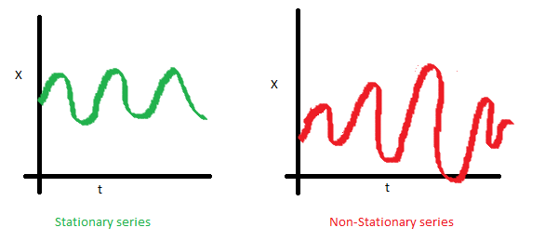

The covariance of the i th term and the (i + m) th term should not be a function of time. In the following graph, you will notice the spread becomes closer as the time increases. Hence, the covariance is not constant with time for the ‘red series’.

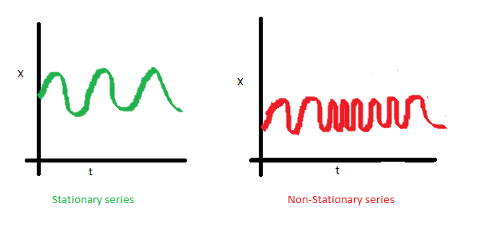

The reason I took up this section first was that until unless your time series is stationary, you cannot build a time series model. In cases where the stationary criterion are violated, the first requisite becomes to stationarize the time series and then try stochastic models to predict this time series. There are multiple ways of bringing this stationarity. Some of them are Detrending, Differencing etc.

Dickey Fuller Test of Stationarity

=> X(t) - X(t-1) = (Rho - 1) X(t - 1) + Er(t)

We have to test if Rho – 1 is significantly different than zero or not. If the null hypothesis gets rejected, we’ll get a stationary time series.

oading the Data Set

Following is the code which will help you load the data set and spill out a few top level metrics.

> data(AirPassengers)

> class(AirPassengers)

[1] "ts"

#This tells you that the data series is in a time series format

> start(AirPassengers)

[1] 1949 1

#This is the start of the time series

> end(AirPassengers)

[1] 1960 12

#This is the end of the time series

> frequency(AirPassengers)

[1] 12

#The cycle of this time series is 12months in a year

> summary(AirPassengers)

Min. 1st Qu. Median Mean 3rd Qu. Max.

104.0 180.0 265.5 280.3 360.

Detailed Metrics

#The number of passengers are distributed across the spectrum

> plot(AirPassengers)

#This will plot the time series

>abline(reg=lm(AirPassengers~time(AirPassengers)))

# This will fit in a line

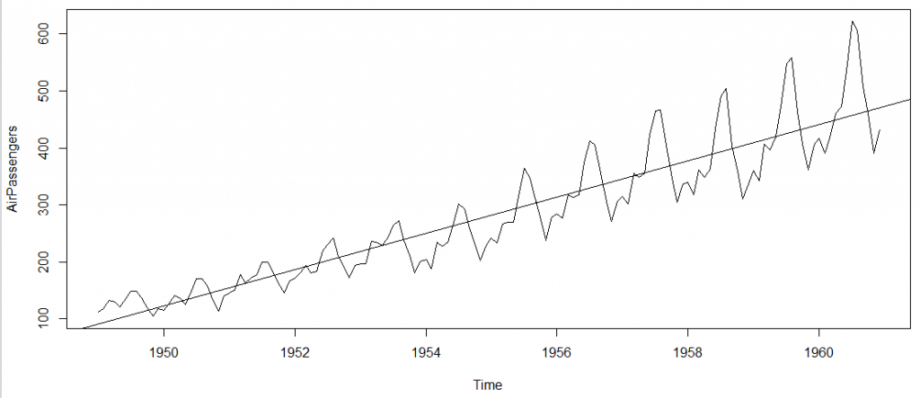

Here are a few more operations you can do:

> cycle(AirPassengers)

#This will print the cycle across years.

>plot(aggregate(AirPassengers,FUN=mean))

#This will aggregate the cycles and display a year on year trend

> boxplot(AirPassengers~cycle(AirPassengers))

#Box plot across months will give us a sense on seasonal effect

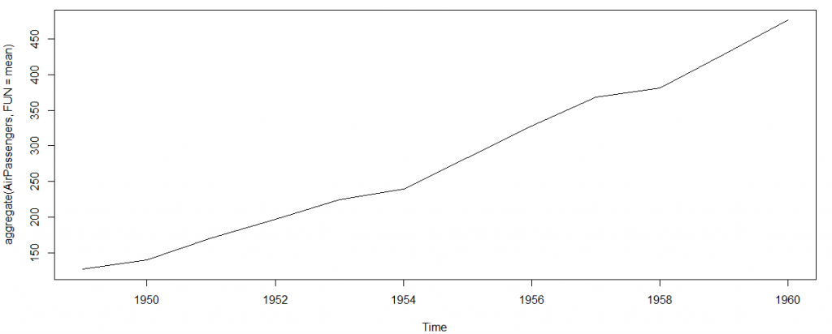

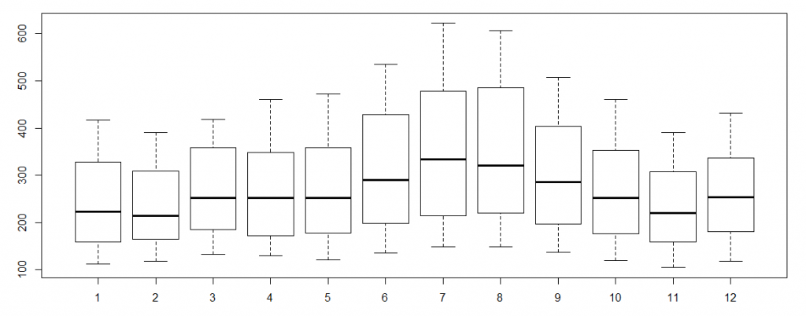

Important Inferences

The year on year trend clearly shows that the #passengers have been increasing without fail.

The variance and the mean value in July and August is much higher than rest of the months.

Even though the mean value of each month is quite different their variance is small. Hence, we have strong seasonal effect with a cycle of 12 months or less.

Exploring data becomes most important in a time series model – without this exploration, you will not know whether a series is stationary or not. As in this case we already know many details about the kind of model we are looking out for.

Introduction to ARMA Time Series Modeling

ARMA models are commonly used in time series modeling. In ARMA model, AR stands for auto-regression and MA stands for moving average.

In case you get a non stationary series, you first need to stationarize the series (by taking difference / transformation) and then choose from the available time series models.

Auto-Regressive Time Series Model

The current GDP of a country say x(t) is dependent on the last year’s GDP i.e. x(t – 1). The hypothesis being that the total cost of production of products & services in a country in a fiscal year (known as GDP) is dependent on the set up of manufacturing plants / services in the previous year and the newly set up industries / plants / services in the current year. But the primary component of the GDP is the former one.

Hence, we can formally write the equation of GDP as:

x(t) = alpha * x(t – 1) + error (t)

This equation is known as AR(1) formulation. The numeral one (1) denotes that the next instance is solely dependent on the previous instance. The alpha is a coefficient which we seek so as to minimize the error function. Notice that x(t- 1) is indeed linked to x(t-2) in the same fashion. Hence, any shock to x(t) will gradually fade off in future.

For instance, let’s say x(t) is the number of juice bottles sold in a city on a particular day. During winters, very few vendors purchased juice bottles. Suddenly, on a particular day, the temperature rose and the demand of juice bottles soared to 1000. However, after a few days, the climate became cold again. But, knowing that the people got used to drinking juice during the hot days, there were 50% of the people still drinking juice during the cold days. In following days, the proportion went down to 25% (50% of 50%) and then gradually to a small number after significant number of days. The following graph explains the inertia property of AR series:

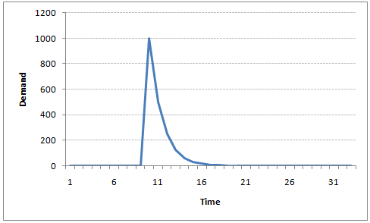

Moving Average Time Series Model

Let’s take another case to understand Moving average time series model.

A manufacturer produces a certain type of bag, which was readily available in the market. Being a competitive market, the sale of the bag stood at zero for many days. So, one day he did some experiment with the design and produced a different type of bag. This type of bag was not available anywhere in the market. Thus, he was able to sell the entire stock of 1000 bags (lets call this as x(t) ). The demand got so high that the bag ran out of stock. As a result, some 100 odd customers couldn’t purchase this bag. Lets call this gap as the error at that time point. With time, the bag had lost its woo factor. But still few customers were left who went empty handed the previous day. Following is a simple formulation to depict the scenario :

x(t) = beta * error(t-1) + error (t)

If we try plotting this graph, it will look something like this :

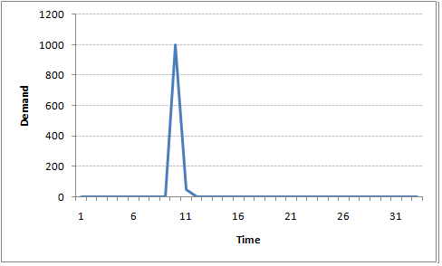

Did you notice the difference between MA and AR model? In MA model, noise / shock quickly vanishes with time. The AR model has a much lasting effect of the shock.

Difference between AR and MA models

The primary difference between an AR and MA model is based on the correlation between time series objects at different time points. The correlation between x(t) and x(t-n) for n > order of MA is always zero. This directly flows from the fact that covariance between x(t) and x(t-n) is zero for MA models (something which we refer from the example taken in the previous section). However, the correlation of x(t) and x(t-n) gradually declines with n becoming larger in the AR model. This difference gets exploited irrespective of having the AR model or MA model. The correlation plot can give us the order of MA model.

Exploiting ACF and PACF plots

Once we have got the stationary time series, we must answer two primary questions:

Q1. Is it an AR or MA process?

Q2. What order of AR or MA process do we need to use?

The trick to solve these questions is available in the previous section. Didn’t you notice?

The first question can be answered using Total Correlation Chart (also known as Auto – correlation Function / ACF). ACF is a plot of total correlation between different lag functions. For instance, in GDP problem, the GDP at time point t is x(t). We are interested in the correlation of x(t) with x(t-1) , x(t-2) and so on. Now let’s reflect on what we have learnt above.

In a moving average series of lag n, we will not get any correlation between x(t) and x(t – n -1) . Hence, the total correlation chart cuts off at nth lag. So it becomes simple to find the lag for a MA series. For an AR series this correlation will gradually go down without any cut off value. So what do we do if it is an AR series?

Here is the second trick. If we find out the partial correlation of each lag, it will cut off after the degree of AR series. For instance,if we have a AR(1) series, if we exclude the effect of 1st lag (x (t-1) ), our 2nd lag (x (t-2) ) is independent of x(t). Hence, the partial correlation function (PACF) will drop sharply after the 1st lag. Following are the examples which will clarify any doubts you have on this concept :

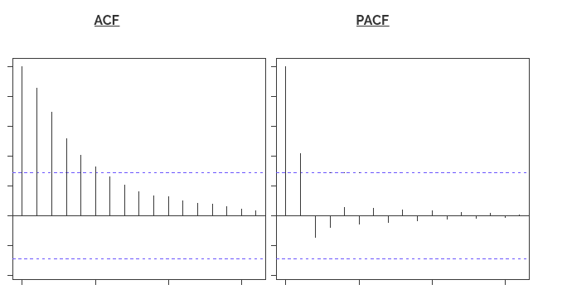

The blue line above shows significantly different values than zero. Clearly, the graph above has a cut off on PACF curve after 2nd lag which means this is mostly an AR(2) process.

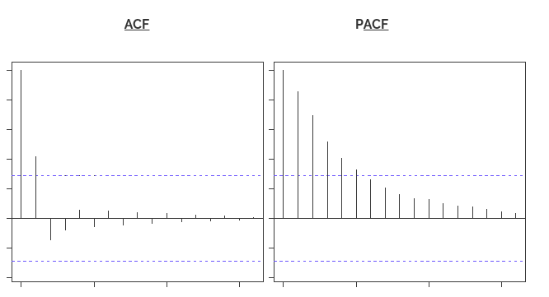

Clearly, the graph above has a cut off on ACF curve after 2nd lag which means this is mostly a MA(2) process.

Till now, we have covered on how to identify the type of stationary series using ACF & PACF plots. Now, I’ll introduce you to a comprehensive framework to build a time series model.  In addition, we’ll also discuss about the practical applications of time series modelling.

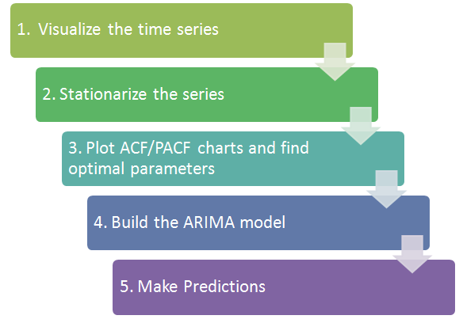

Step 1: Visualize the Time Series

It is essential to analyze the trends prior to building any kind of time series model. The details we are interested in pertains to any kind of trend, seasonality or random behaviour in the series. We have covered this part in the second part of this series.

Step 2: Stationarize the Series

Once we know the patterns, trends, cycles and seasonality , we can check if the series is stationary or not. Dickey – Fuller is one of the popular test to check the same. We have covered this test in the first part of this article series. This doesn’t ends here! What if the series is found to be non-stationary?

There are three commonly used technique to make a time series stationary:

1. Detrending : Here, we simply remove the trend component from the time series. For instance, the equation of my time series is:

x(t) = (mean + trend * t) + error

We’ll simply remove the part in the parentheses and build model for the rest.

2. Differencing : This is the commonly used technique to remove non-stationarity. Here we try to model the differences of the terms and not the actual term. For instance,

x(t) – x(t-1) = ARMA (p , q)

This differencing is called as the Integration part in AR(I)MA. Now, we have three parameters

p : AR

d : I

q : MA

3. Seasonality : Seasonality can easily be incorporated in the ARIMA model directly. More on this has been discussed in the applications part below.

Step 3: Find Optimal Parameters

The parameters p,d,q can be found using ACF and PACF plots. An addition to this approach is can be, if both ACF and PACF decreases gradually, it indicates that we need to make the time series stationary and introduce a value to “d”.

Step 4: Build ARIMA Model

With the parameters in hand, we can now try to build ARIMA model. The value found in the previous section might be an approximate estimate and we need to explore more (p,d,q) combinations. The one with the lowest BIC and AIC should be our choice. We can also try some models with a seasonal component. Just in case, we notice any seasonality in ACF/PACF plots.

Step 5: Make Predictions

Once we have the final ARIMA model, we are now ready to make predictions on the future time points. We can also visualize the trends to cross validate if the model works fine.

Example:

Where did we start ?

Following is the plot of the number of passengers with years. Try and make observations on this plot before moving further in the article.

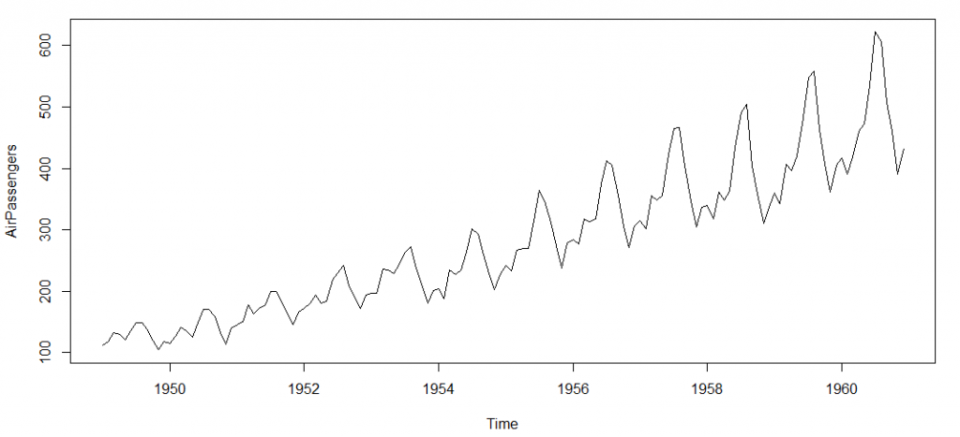

Here are my observations :

1. There is a trend component which grows the passenger year by year.

2. There looks to be a seasonal component which has a cycle less than 12 months.

3. The variance in the data keeps on increasing with time.

We know that we need to address two issues before we test stationary series. One, we need to remove unequal variances. We do this using log of the series. Two, we need to address the trend component. We do this by taking difference of the series. Now, let’s test the resultant series.

adf.test(diff(log(AirPassengers)), alternative="stationary", k=0)

Augmented Dickey-Fuller Test

data: diff(log(AirPassengers))

Dickey-Fuller = -9.6003, Lag order = 0,

p-value = 0.01

alternative hypothesis: stationary

We see that the series is stationary enough to do any kind of time series modelling.

Next step is to find the right parameters to be used in the ARIMA model. We already know that the ‘d’ component is 1 as we need 1 difference to make the series stationary. We do this using the Correlation plots. Following are the ACF plots for the series :

acf(log(AirPassengers))

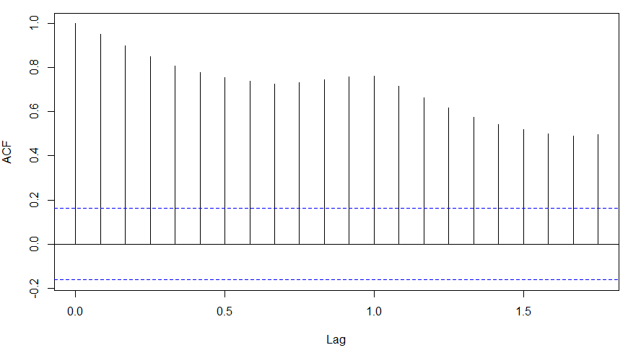

What do you see in the chart shown above?

Clearly, the decay of ACF chart is very slow, which means that the population is not stationary. We have already discussed above that we now intend to regress on the difference of logs rather than log directly. Let’s see how ACF and PACF curve come out after regressing on the difference.

acf(diff(log(AirPassengers)))

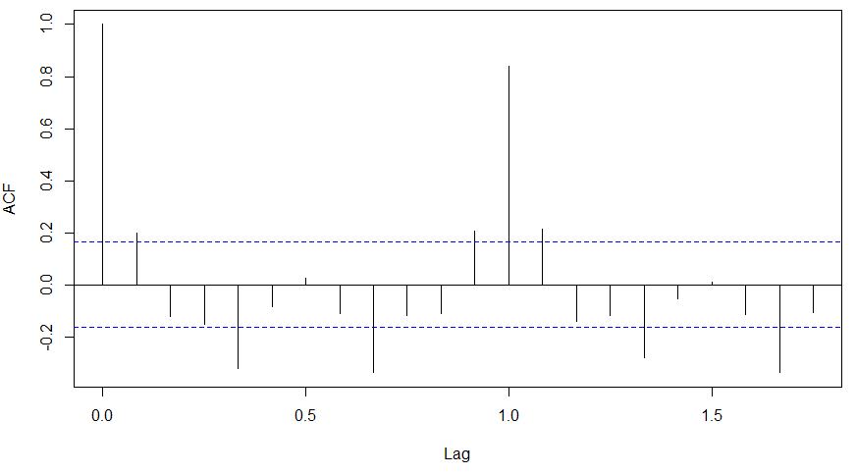

pacf(diff(log(AirPassengers)))

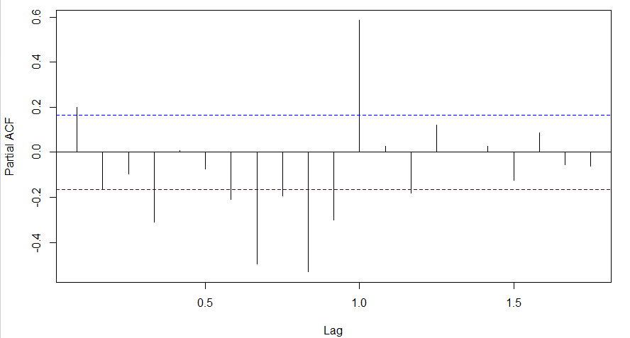

Clearly, ACF plot cuts off after the first lag. Hence, we understood that value of p should be 0 as the ACF is the curve getting a cut off. While value of q should be 1 or 2. After a few iterations, we found that (0,1,1) as (p,d,q) comes out to be the combination with least AIC and BIC.

Let’s fit an ARIMA model and predict the future 10 years. Also, we will try fitting in a seasonal component in the ARIMA formulation. Then, we will visualize the prediction along with the training data. You can use the following code to do the same :

(fit <- arima(log(AirPassengers), c(0, 1, 1),seasonal = list(order = c(0, 1, 1), period = 12)))

pred <- predict(fit, n.ahead = 10*12)

ts.plot(AirPassengers,2.718^pred$pred, log = "y", lty = c(1,3))

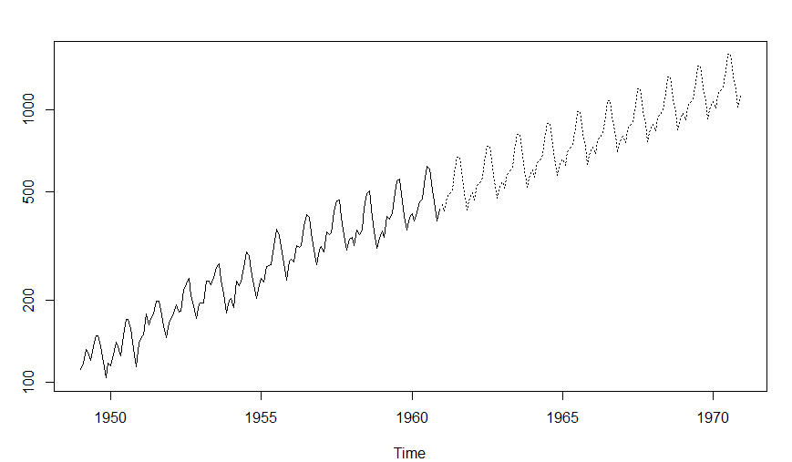

<https://www.coindesk.com/10-must-read-cryptocurrency-research-papers-from-2015/>

https://www.genesis-mining.com/infographic/what-do-leaders-say-about-bitcoin



<https://www.thebalance.com/what-is-the-sandp-500-3305888>

The S&P 500 is a stock market index that tracks the 500 most widely held stocks ​on the New York Stock Exchange or NASDAQ. It seeks to represent the entire stock market by reflecting the risk and return of all large cap companies.

To be included in the S&P 500, a company must be located in the United States and have a market cap of at least $5.3 billion. At least 50 percent of the corporation's stock must be available to the public. Its stock price must be at least $1 per share. Finally, it must have at least four consecutive quarters of positive earnings.

The makeup of the S&P 500 industries reflects that of the economy. The 2017 sector percentages in the S&P 500 were Information Technology (23.2 percent), Health Care (13.9 percent), Financials (13.7 percent), Consumer Discretionary (12.5 percent), Consumer Staples (9.4 percent), Utilities (3.3 percent), Materials (2.8 percent) and Telecom Services (2.2 percent).

The S&P 500 has fewer large cap stocks than the Dow Jones Industrial Average. The Dow tracks the share price of 30 companies that best represent their industries. Its market capitalization accounts for almost one-quarter of the U.S. stock market. The Dow is the most quoted market indicator in the world.

The S&P 500, like any measurement of the stock market, is often used as an leading economic indicator of how well the U.S. economy is doing.

<https://etfguide.com/heres-why-a-total-market-approach-is-better-vs-the-sp-500/>

Last year, Warren Buffett said he would direct the trustees of his estate to put 90% of his remaining assets in an S&P 500 index fund and 10% in short-term government bonds.

<http://www.investopedia.com/ask/answers/041315/what-are-pros-and-cons-using-sp-500-benchmark.asp>

Many investors also use the S&P 500 as a benchmark for their individual portfolios. The central advantage of using the S&P 500 as a benchmark is the wide market breadth of the large-cap companies included in the index. The index can provide a broad view on the economic health of the United States.

However, there are disadvantages to using the S&P 500 as a benchmark for individual portfolio performance. Most investors are widely diversified in assets other than stock, such as bonds, precious metals and cash, the values of which are not reflected in the S&P 500. The index contains only larger market cap companies from the United States. In contrast, investors may own small-cap or foreign companies in their portfolios. Using the S&P 500 as a benchmark may be an inaccurate measure of portfolio return for individual investors.

The S&P 500 has become the leading stock index due to its broader scope. Many hedge funds compare their annual performance to the S&P 500, seeking to realize alpha in excess of the index's returns.

another advantage of the S&P 500 is that components of the index are updated on a quarterly basis. A committee determines which companies to include in the index. The factors considered include a market capitalization in excess of $5.3 billion, a public float of at least 50%, headquarters in the U.S., adequate liquidity and financial viability. Companies must have traded for six to 12 months after their initial public offerings (IPOs) before being considered for inclusion in the index.

A:

The Standard & Poor's 500 Index is the most commonly used benchmark for determining the state of the overall economy. Many investors also use the S&P 500 as a benchmark for their individual portfolios. The central advantage of using the S&P 500 as a benchmark is the wide market breadth of the large-cap companies included in the index. The index can provide a broad view on the economic health of the United States.

However, there are disadvantages to using the S&P 500 as a benchmark for individual portfolio performance. Most investors are widely diversified in assets other than stock, such as bonds, precious metals and cash, the values of which are not reflected in the S&P 500. The index contains only larger market cap companies from the United States. In contrast, investors may own small-cap or foreign companies in their portfolios. Using the S&P 500 as a benchmark may be an inaccurate measure of portfolio return for individual investors.

The Dow Jones Industrial Average used to be the main gauge of economic health for the United States, but that index only contains 30 companies and is limited in the sectors it represents. The S&P 500 has become the leading stock index due to its broader scope. Many hedge funds compare their annual performance to the S&P 500, seeking to realize alpha in excess of the index's returns.

In addition to its broad scope, another advantage of the S&P 500 is that components of the index are updated on a quarterly basis. A committee determines which companies to include in the index. The factors considered include a market capitalization in excess of $5.3 billion, a public float of at least 50%, headquarters in the U.S., adequate liquidity and financial viability. Companies must have traded for six to 12 months after their initial public offerings (IPOs) before being considered for inclusion in the index. As of 2015, the index contains assets valued at around $1.7 trillion. By updating the index components, the index can accurately reflect the state of the large-cap market.

A drawback to using the S&P 500 for benchmark purposes is that the index is disproportionately weighted towards larger companies.

<http://www.investopedia.com/terms/a/alpha.asp>

What is 'Alpha'

Alpha is used in finance to represent two things:

1. A measure of performance on a risk-adjusted basis.

Alpha, often considered the active return on an investment, gauges the performance of an investment against a market index used as a benchmark, since they are often considered to represent the market’s movement as a whole. The excess returns of a fund relative to the return of a benchmark index is the fund's alpha.

Alpha is most often used for mutual funds and other similar investment types. It is often represented as a single number (like 3 or -5), but this refers to a percentage measuring how the portfolio or fund performed compared to the benchmark index (i.e. 3% better or 5% worse).

Alpha is often used with beta, which measures volatility or risk, and is also often referred to as “excess return” or “abnormal rate of return.”

2. The abnormal rate of return on a security or portfolio in excess of what would be predicted by an equilibrium model like the capital asset pricing model (CAPM).

In this context, alpha is often known as the “Jensen index.”

BREAKING DOWN 'Alpha'

1. Alpha is one of five technical risk ratios; the others are beta, standard deviation, R-squared, and the Sharpe ratio. These are all statistical measurements used in modern portfolio theory (MPT). All of these indicators are intended to help investors determine the risk-return profile of a mutual fund.

Because alpha represents the performance of a portfolio relative to a benchmark, it is often considered to represent the value that a portfolio manager adds to or subtracts from a fund's return. In other words, alpha is the return on an investment that is not a result of general movement in the greater market. As such, an alpha of 0 would indicate that the portfolio or fund is tracking perfectly with the benchmark index and that the manager has not added or lost any value.

investors could hold their portfolio managers to a higher standard of just producing returns: producing returns greater than the investor would have made with a blanket market-wide portfolio.

<https://www.thebalance.com/what-market-indexes-tell-us-3141365>

The number is not important. What is important is the percent change over time. This movement up or down gives you and idea of how the index is performing.

What’s Good about Indexes

Indexes provide useful information including:

Even with their limitations, indexes show trends and changes in investing patterns.

They give us snapshots, even if they are out of focus.

Indexes provide a yardstick for comparison.

<https://seekingalpha.com/article/3302915-why-beating-the-s-and-p-500-is-so-hard-and-why-even-protecting-against-a-10minus-15-percent-correction-matters>

We will discuss how the S&P 500 can send a distorted message on the strength or weakness of US equity markets, and other benchmarks US investors can use to serve as advance warning indicators to raise cash and assume a more defensive posture, well before the mainstream.

To continue with the discussion on the S&P 500 indexes and its limitations...

It has to do with how the index is constructed, in short winning stocks are rewarded with a larger weighting in the index, poor performers ultimately degrade to a meaningless weighting (or are kicked out), in an ongoing re-weighting process that ensures the success of the index compared to the overall universe of US stocks.

The index consistently rewards winners, making it both difficult to outperform the index, and masking broader market weakness, as these stars are not the first to correct, but the last.

The reason for this trend has to do with investor, and especially institutional behavior at the commencement of corrective activity in the broader market.

In the incipient stages of corrective activity, institutions will often not go right to cash but increase their allocation to the largest, highest quality S&P 500 stocks as a defensive measure, at the expense of a larger group of secondary, smaller, perceived weaker stocks.

This is also partially for appearance sake - funds always desire to show winners on their quarterly end statements as a marketing exercise. Therefore, in the latter stages of a bull trend, the primary indexes look fine as money flows into an ever narrowing group of heavily index weighted stocks.

Even though a technology stock like AAPL is still considered a growth stock, it is now also considered a defensive place to maintain an investment allocation and collect the dividend during uncertain or corrective market periods.

It is exactly this behavior that explains why subsection and market breadth indicators usually break down first in a correction, then ultimately the S&P 500 as finally money flows from the leaders to cash or bonds as a greater safe haven.

I trust I've illustrated, if and when the S&P 500 next experiences a 10-15%, multi-week correction - and we haven't had one since 2011 - the actual mark-to-market losses may exceed 30-50% on many stocks from their highs (and some are already there, particularly in the energy sector), possibly pressuring selling at an unfavorable time among overallocated investors.

<https://www.noozhawk.com/article/craig_allen_russell_2000_market_direction_indicator_20131103>

In an effort to identify possible signs of a change in market direction, we can look to the relationship between the S&P 500 and the Russell 2000 small-cap index — a relationship that has provided reliable guidance in the past.

If we think about the relationship between the Russell and the S&P 500, it makes sense that the Russell would move first because it is an index comprised exclusively of small-capitalization companies. Small companies tend to be earlier-stage, with high growth rates, and are therefore more sensitive to economic conditions, and riskier than larger, more-established companies that make up the S&P 500, which contains roughly 80 percent large companies.

Similar to a canary in a coal mine, small company stocks tend to be highly reactive to changes in economic conditions, or to changes in investor sentiment regarding the economy and the stock market.

The Price Response to S&P 500 Index Addtions and Deletions PDF

There is a permanent increase in price from addition a no permanent decline from deletion because of investor awareness.

Indices Builder Tool example

<https://www.trading-tools.com/onlinemanuals/indicesbuilder%20documentation.pdf>

<http://www.aaii.com/investing-basics/article/market-barometers-a-look-at-stock-indexes-and-how-they-work>

A stock market index is simply a statistical composite that measures the ups and downs of the market it is designed to follow. There are many indexes that follow numerous segments of the stock market, including the broad stock market and more narrow sectors such as specific industries or specific types of stocks (such as large or small firms).

Indexes serve purposes other than just stock market barometers. Investors use indexes in monitoring their own portfolios, and as benchmarks for performance comparisons.

Most indexes calculate the value of their composite stocks at a certain point in time and set this value as the base, or starting point. All future values can be compared to this base.

For example, an index with a base of 100 (other bases may be used) and a current value of 200 has doubled over the time period.

While this approach is by far the most common construction, averages also exist—most notably the Dow Jones industrial average.

A market index first and foremost consists of a defined sample of securities, selected by the creators of the index.

The other issue in creating an index is the percentage amount of each stock that is represented in the index. Typically, this is referred to as the index “weighting.”

Marketcap

In a capitalization-weighted index, the larger capitalization stocks will represent a greater proportion of the index, and changes in those stocks will have a bigger impact on the index value. In a capitalization-weighted index, a stock’s price dictates how much of each firm is represented in the index (since its market cap is number of shares outstanding times the stock price), and stocks that have hefty price increases automatically become larger holdings.

Equal-Weighted

Another approach is to weight all stocks equally—in other words, stocks of all sizes have equal representation. Each stock is held in proportion to its market capitalization. Equal-weighted indexes reflect the movements of all stocks in the index without regard to the price and shares outstanding; small stocks have just as much impact as large stocks.

Price

The third method of determining the amount of stock to be represented in an index is based on price. Although not common, it is the method used by the Dow Jones industrial average. In a price-weighted index, a stock’s weight in the index is determined by share price alone, so that higher-priced stocks have more influence than lower-priced stocks. That means that a percentage increase in a higher-priced stock (for instance, a 1% price increase in a $100 stock) will influence the index more than the same percentage increase in a lower-priced stock (for instance, a 1% price increase in a $10 stock). On the other hand, a $1 price change for an expensive stock will have the same effect as a $1 price change for a lower-priced stock.

Other

The immense popularity of index funds—and now exchange-traded funds—has led to the creation of hundreds of new stock indexes. The bulk of these indexes have been created to follow every conceivable stock market segment, and most of these are market-cap weighted.

**A new group of indexes has been created to allow the use of fundamental “qualitative” factors to determine stock composition, adding a semi-active flavor to the composition of the index.** The are primarily used within companies for index-related mutual funds and ETFs.

Market-cap-weighted indexes will be dominated by larger firms, even if they are “total market” indexes covering firms of all sizes.

Equal-weighted indexes will tell you how each of the sample stocks has performed, regardless of the size of the firm.

Price-weighted indexes emphasize the performance of expensive stocks while cap-weighted indexes emphasize the performance of large-cap stocks.

If you are using an index to monitor your own portfolio, make sure you use an index (or several indexes) that mirrors your own portfolio composition and diversity. Comparing performance of a portfolio to an inappropriate index may lead to less than optimal investment decisions.

Momentum

Value investing is a long-term strategy. Momentum is a short-term strategy. A value investor believes a stock can become over/under valued based on relative earnings or discounted cash flow measures. Are cryptos really value??

Momentum is not concerned with operational performance, at least not from a pricing perspective. They look at indicators that help to track the trend and spend a great deal of time looking for patterns that confirm trend continuation.

Momentum indicators:

* trend line,
* 50-period moving average – when price drops or rises above this average, it is a confirmation the price is trending and a signal to buy or sell.

“Momo” Index or Fund?

Include/exclude coins based on momentum.

Confirmation

Using more than one indicator to determine a buy or sell like an ensemble. For example, trend, momentum, volatility, and volume.

Trend indicators – moving averages, moving average convergence divergence, parabolic SAR

Momentum indicators – stochastic oscillator, commodity channel index, relative strength index

Volatility indicators – Bollinger bands, standard deviation, and average true range

Volume indicators – chaikin oscillator, on-balance volume, and volume rate of change

Commodity Selection Index – CSI

A technical momentum indicator that attempts to identify which commodities are the most suitable for short-term trading. The larger the CSI value, the stronger is the trend and volatility characteristics associated with the asset. This indicator should only be used by traders who can handle large amounts of volatility as it indicates strong trending, but reversals are always possible.

Short-term traders know that the key to making money is movement, which is the reason that they mainly focus on the highly volatile assets. This index attempts to lessen the amount of risk taken, and make it easier to trade by incorporating trend characteristics.

Market Breadth

Market breadth is a technique used in technical analysis that attempts to gauge the direction of the overall market by analyzing the number of companies advancing relative to the number declining. Positive market breadth occurs when more companies are moving higher than are moving lower, and it is used to suggest that the bulls are in control of the momentum. Conversely, a disproportional number of declining securities is used to confirm bearish momentum.

<https://www.r-bloggers.com/forecasting-stock-returns-using-arima-model/>